Welcome to the Greene County Office Building

located at 411 Main St. Catskill, NY

Home of Greene County Family Planning

There is a front entrance and back entrance.
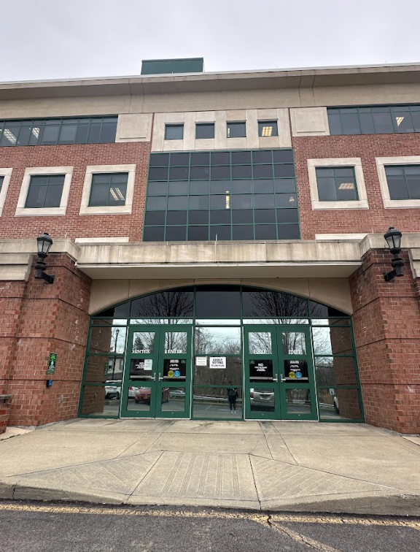
Main St Entrance
Front of Building – 2nd Floor
(Family Planning located upstairs)
Water St Entrance
Back of Building – 1st floor
(parking lot access behind back entrance)

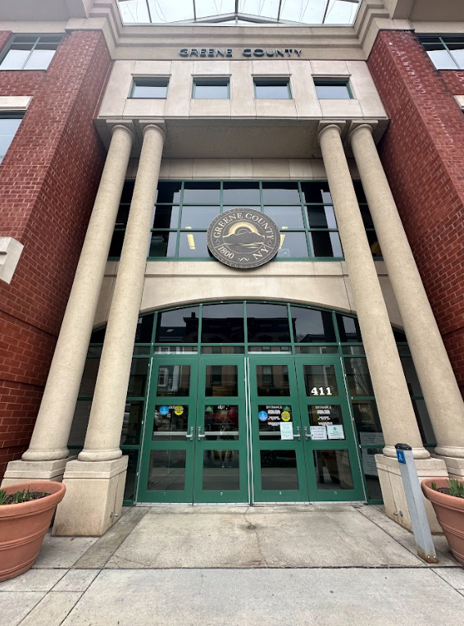

Come on in!

  - Next are the metal detectors. If you don’t need it, don’t bring it! This will make getting through the security screening quicker.

  - Absolutely NO weapons or knives allowed in the building. This security is for your safety as well as ours.

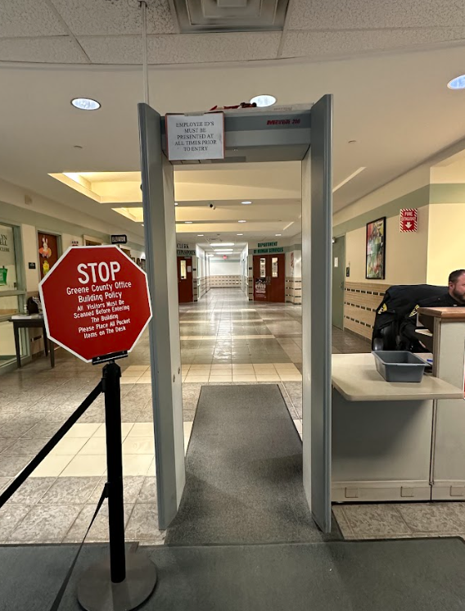

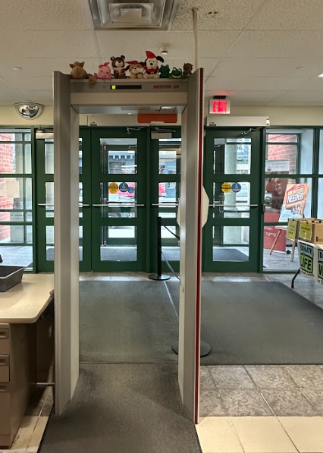

  - Just down the hall are the elevators.

  - Take the elevator to the third floor.

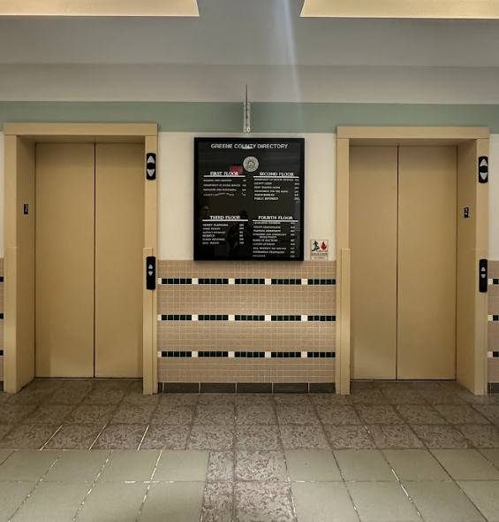
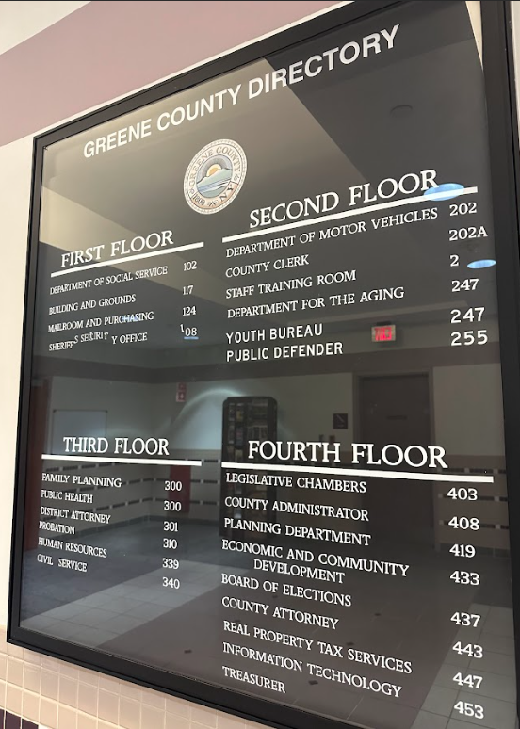

  - Get off at the third floor and look to your left. You will see the doors leading into Greene County Public Health & Family Planning. Go through these doors…
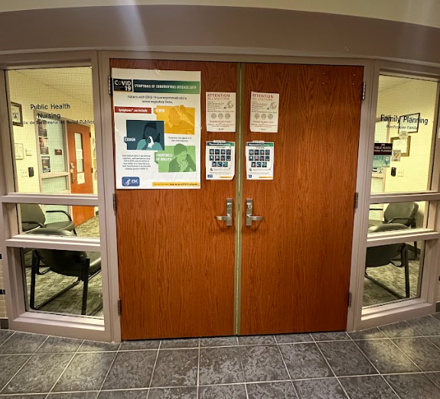

  - Press the call button on the buzzer and wait to be let in to the Family Planning waiting room on your right-hand side.

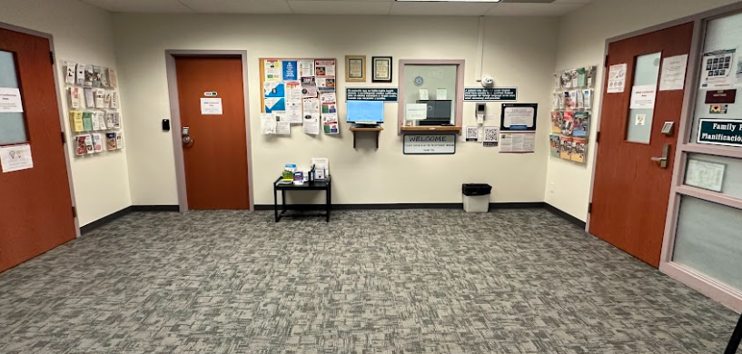

  - When you first walk in, there is a check-in kiosk. While you wait for your appointment, take a look at all the brochures and pamphlets! You could help teach others about these important healthcare issues.
  - And, please let others know about Greene County Family Planning. Our clients are our best advertising!
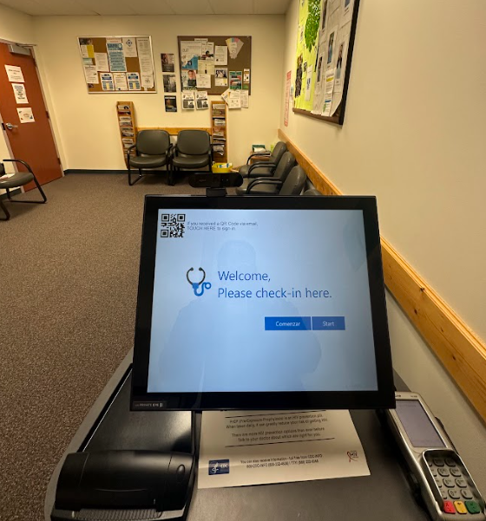
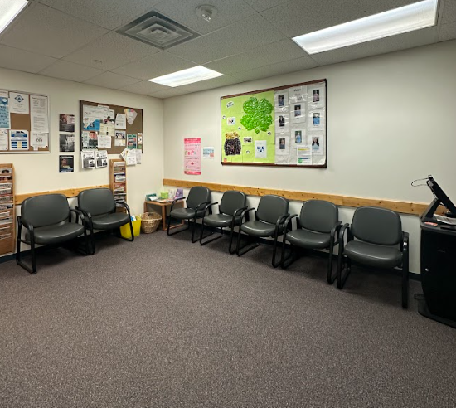

Here are our lovely exam rooms!
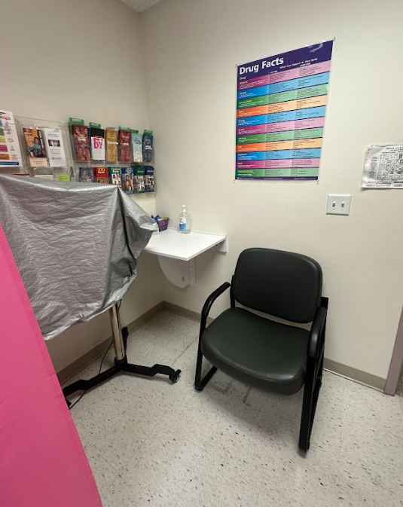
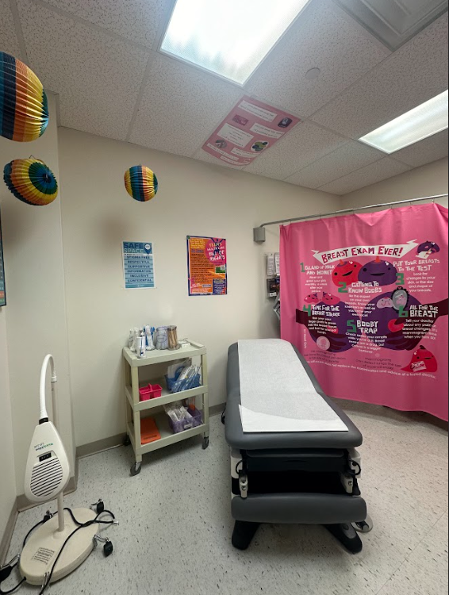
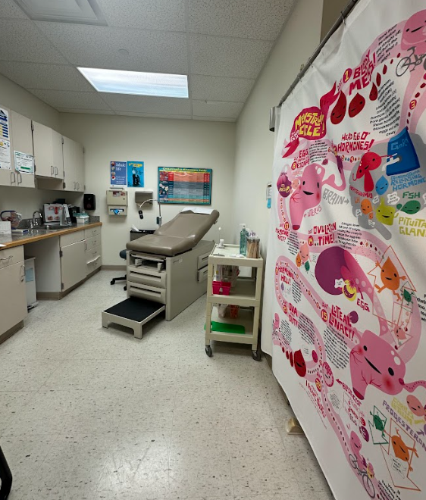
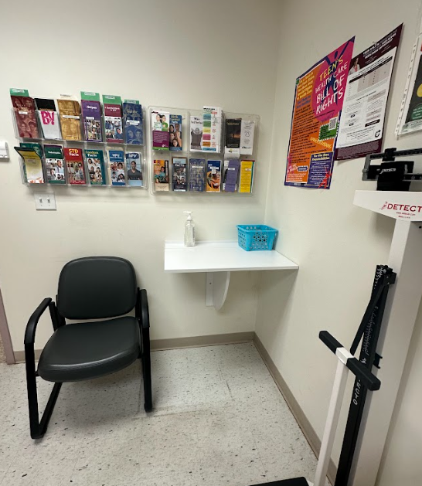

  - Isn’t it beautiful at Greene County Family Planning?
  - Thank you for taking the photo tour of
  - Greene County Family Planning.
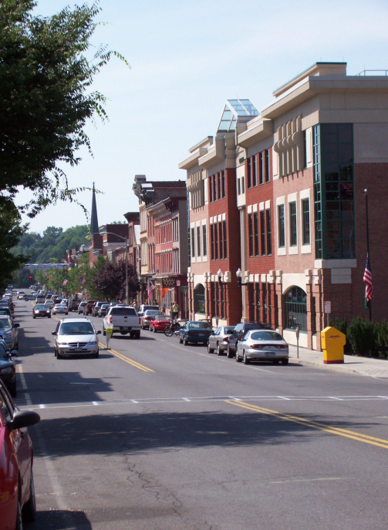

  - While in town, why not check out Main St? There are many wonderful restaurants and shops. If you are here in the Summer, you might see Catskill’s famous cats!

