Do you have a family member with a mental health diagnosis?
Learn more about NAMI!
What: The National Association on Mental Illness is a national organization that provides support to individuals with mental health diagnoses and their families. Our local chapter is the Greene County Chapter. Learn more about NAMI and how it can support you and your loved ones at NAMI informational meetings.
When: Every Thursday evening from 6:00-6:45pm beginning May 2, 2019
Where: Greene County Mental Health Center, 905 Greene County Office Building (Angelo Canna Town Park) in Cairo
Cost: There is no cost to attend these meetings
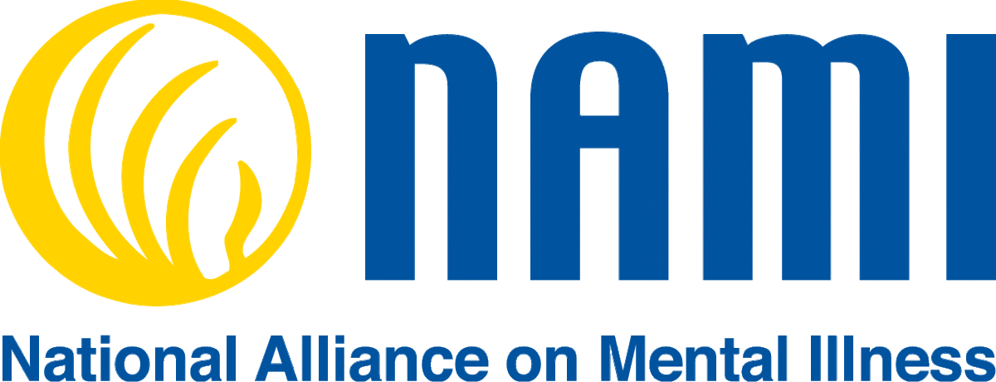

For more information, contact Judi McGuire at Greene County Mental Health at 518-622-9163 xt 7162

